**ADVANCED DBMS LAB**

**CYCLE -2**

**PL/SQL Programs (Trigger, Cursor, Stored Procedures and Functions)**

|  |  |
| --- | --- |
| **CO 2** | Apply PL/SQL for processing databases |

LIYA V JOHN

ROLL NO:14

B, S2, MCA

1. Write a PL/SQL code to accept the text and reverse the given text. Check the text is palindrome or not.

Program Code:

**CASE 1:**

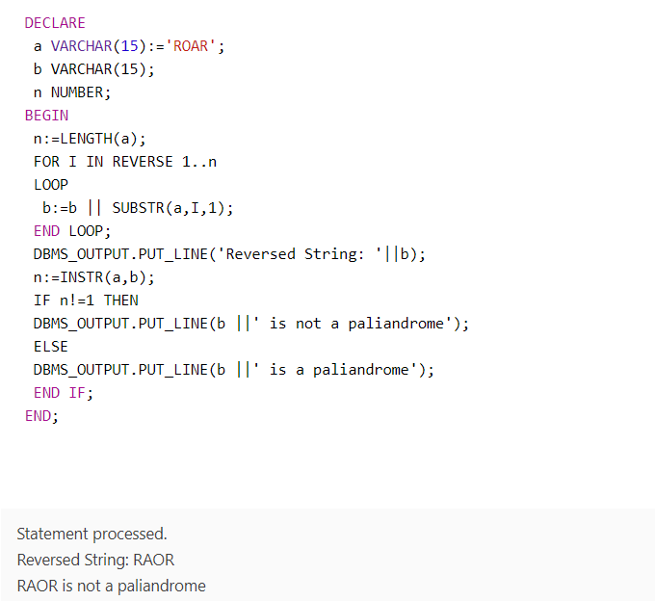

OUTPUT:



**CASE 2:**

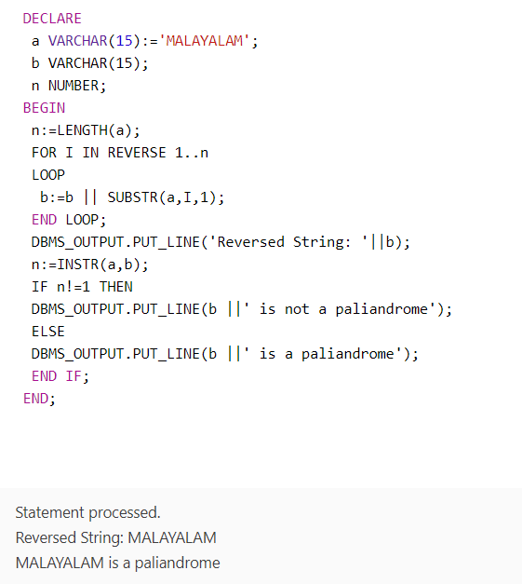

OUTPUT:



1. Write a program to read two numbers; If the first no > 2nd no, then swap the numbers; if the first number is an odd number, then find its cube; if first no < 2nd no then raise it to its power; if both the numbers are equal, then find its sqrt.

Program code:

**CASE 1:**

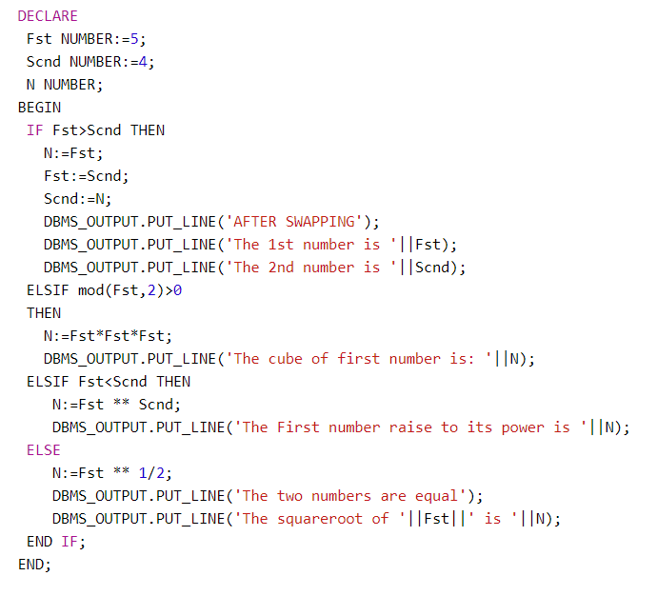

OUTPUT:

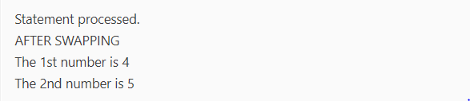

**CASE 2:**

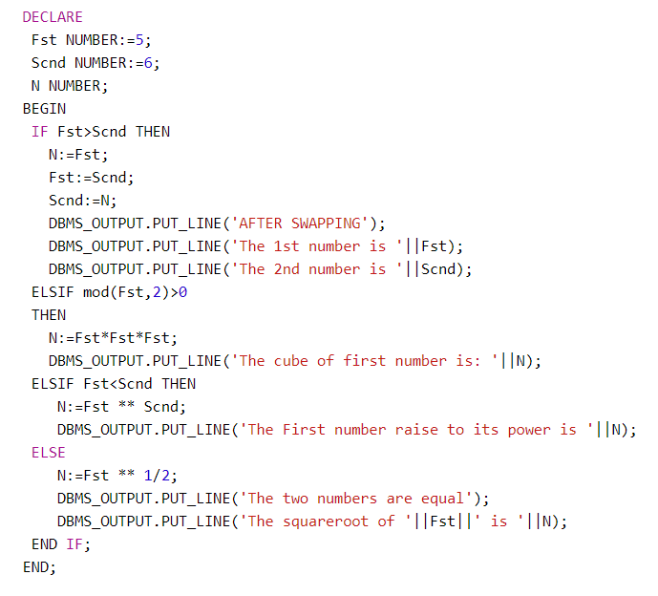

OUTPUT:

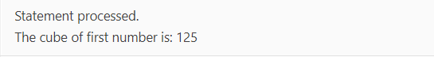

**CASE 3:**

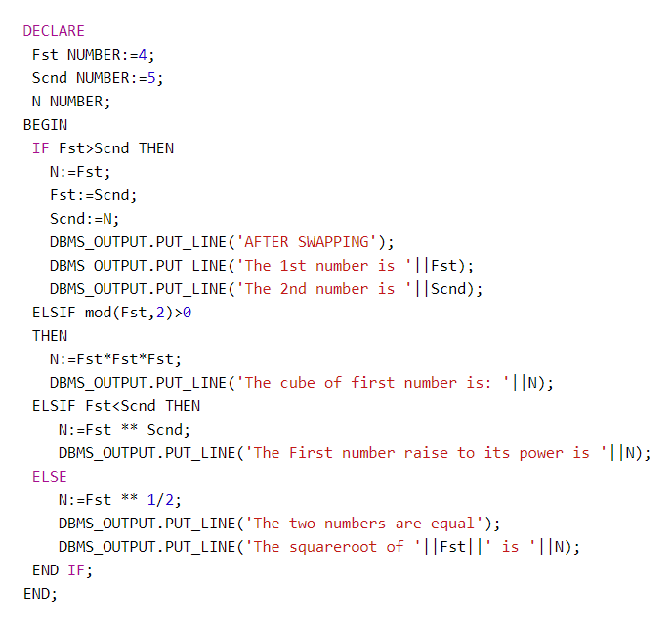

OUTPUT:

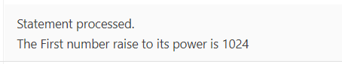

**CASE 4:**

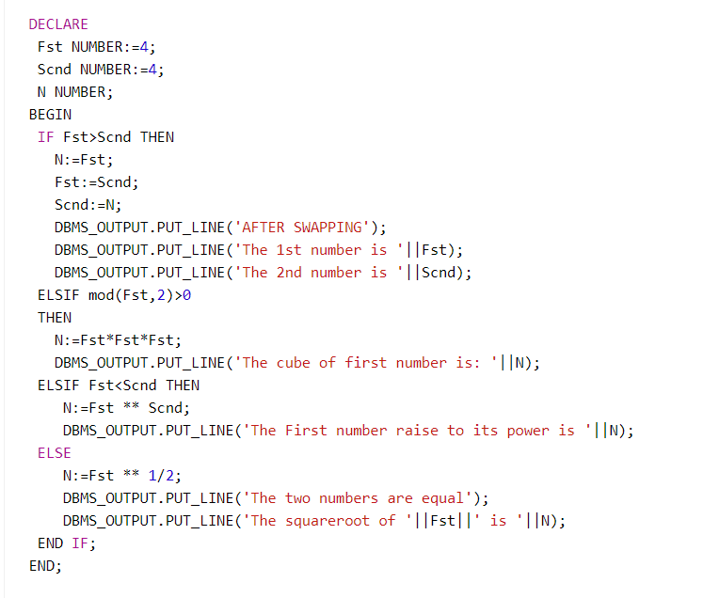

OUTPUT:

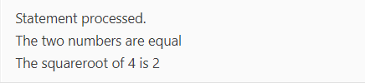

1. Write a program to generate first 10 terms of the Fibonacci series.

Program code:

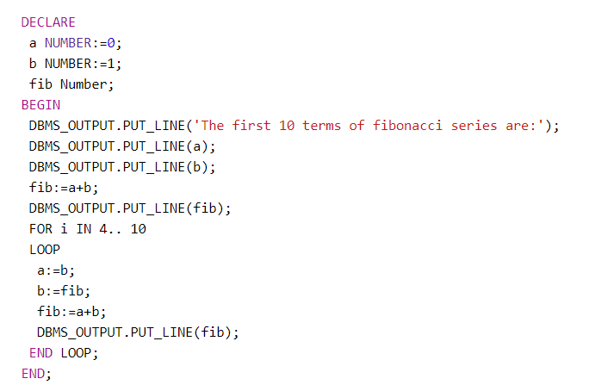

OUTPUT:

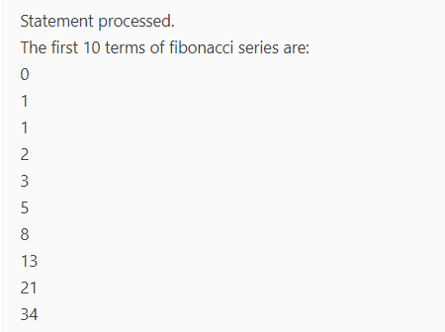

1. Write a PL/SQL program to find the salary of an employee in the EMP table (Get the empno from the user). Find the employee drawing minimum salary. If the minimum salary is less than 7500, then give an increment of 15%. Also create an emp %rowtype record. Accept the empno from the user, and display all the information about the employee.

Program code:

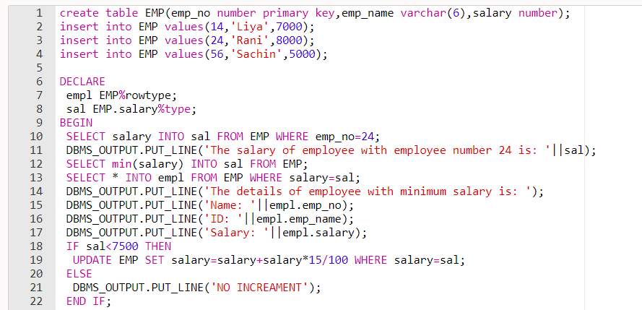

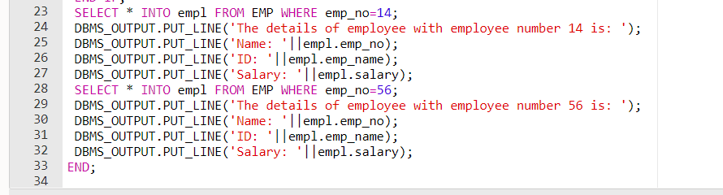

OUTPUT:

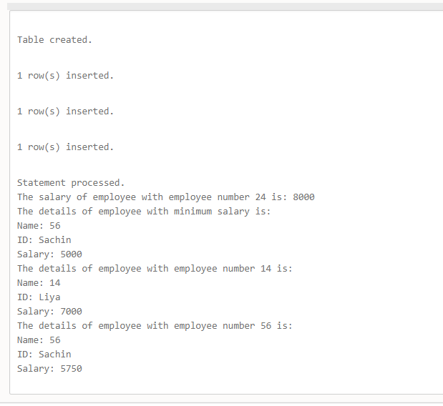

1. Write a PL/SQL **function** to find the total strength of students present in different classes of the MCA department using the table Class(ClassId, ClassName, Strength);

Program code:

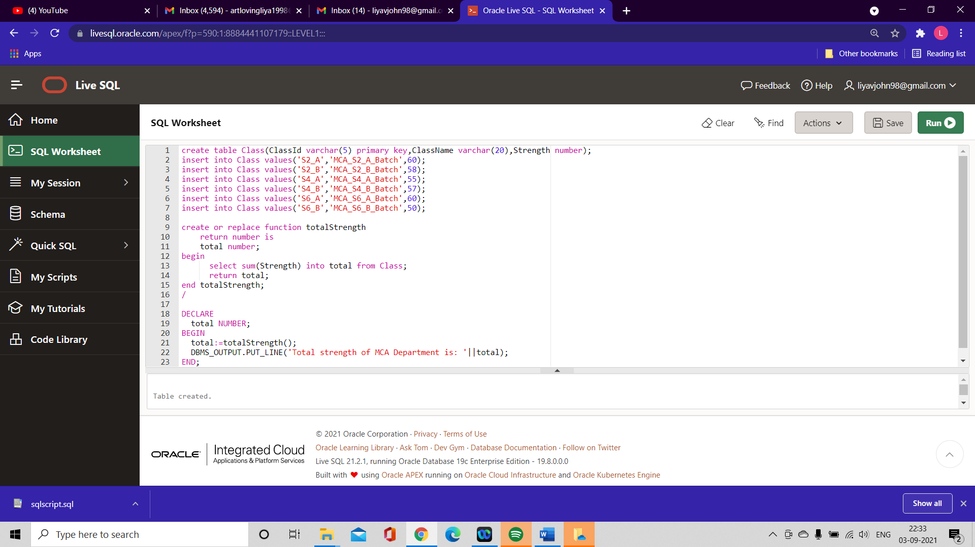

OUTPUT:

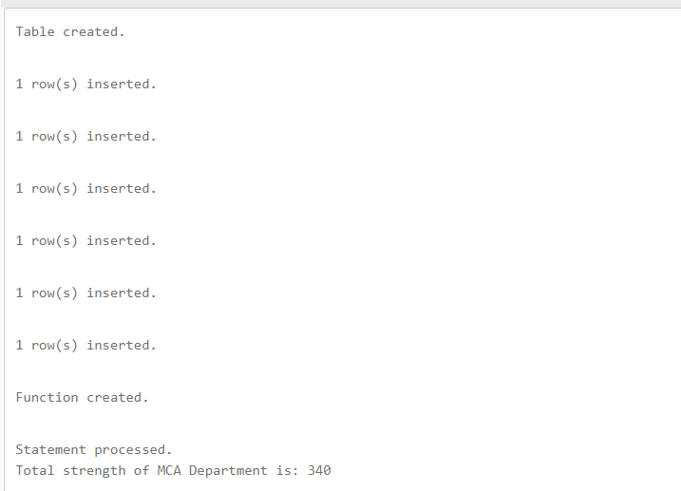

1. Write a PL/SQL **procedure** to increase the salary for the specified employee. Using empno in the employee table based on the following criteria: increase the salary by 5% for clerks, 7% for salesman, 10% for analyst and 20 % for manager. Activate using PL/SQL block.

**Program Code:**

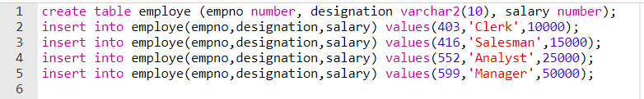

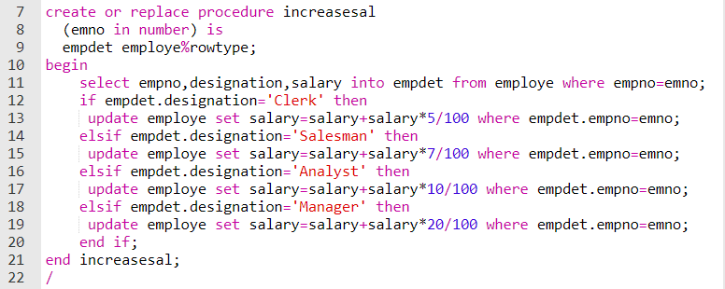

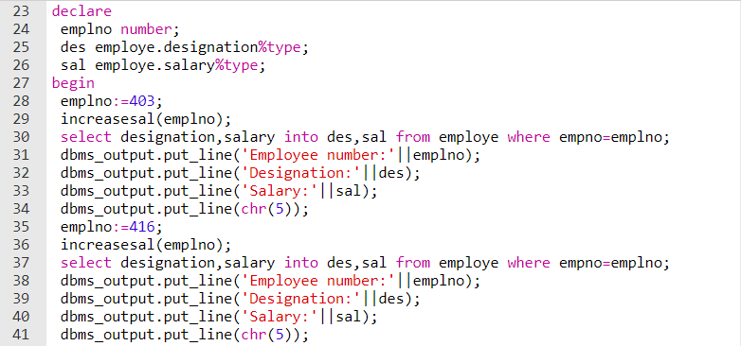

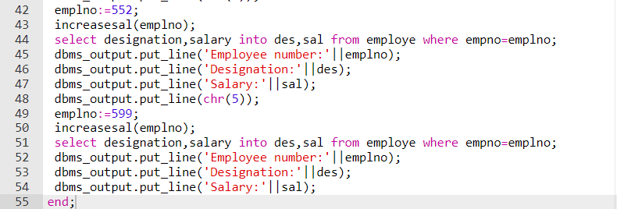

**OUTPUT:**

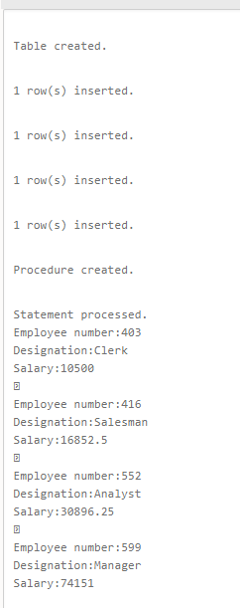

1. Create a **cursor** to modify the salary of ‘president’ belonging to all departments by 50%.

**Program Code:**

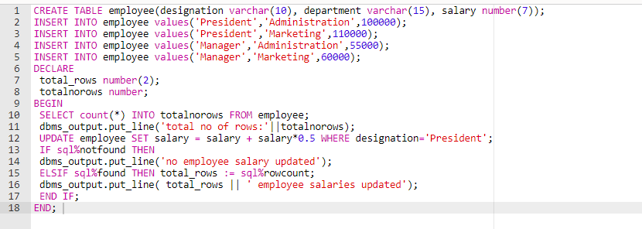

**OUTPUT:**

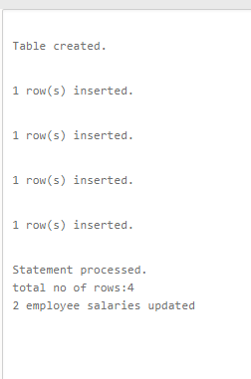

1. Write a **cursor** to display list of Male and Female employees whose name starts with S.

**Program Code:**

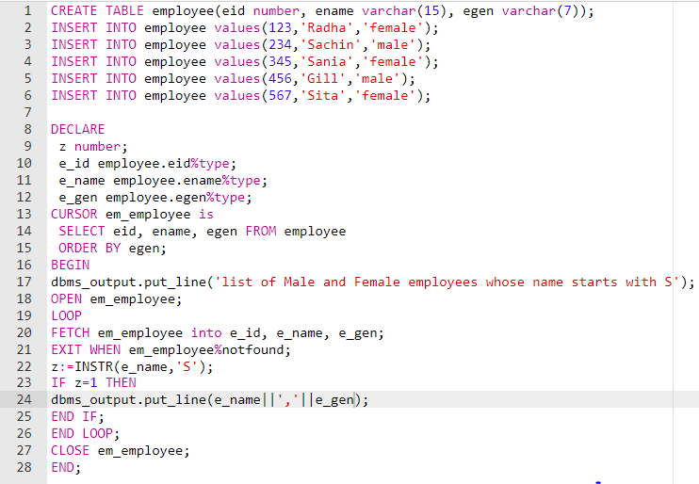

**OUTPUT:**

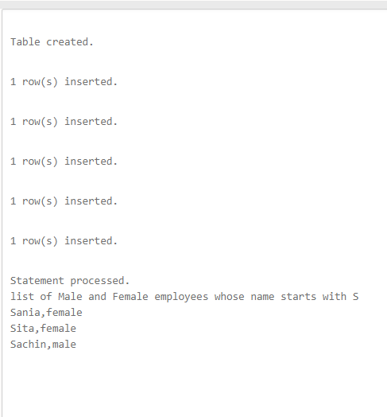

1. Create the following tables for Library Information System: Book : (accession-no, title, publisher, publishedDate, author, status). Status could be issued, present in the library, sent for binding, and cannot be issued. Write a **trigger** which sets the status of a book to "cannot be issued", if it is published 15 years back.

**Program Code:**

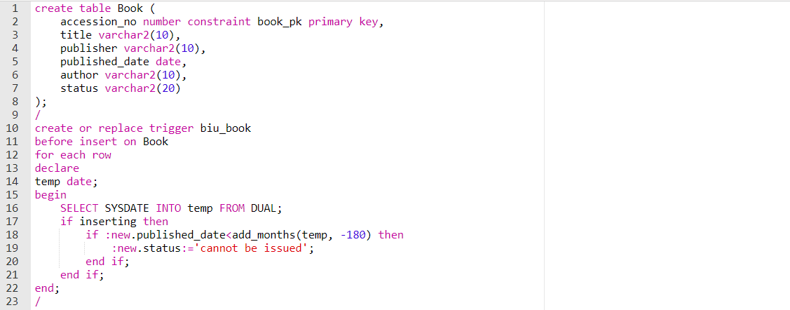

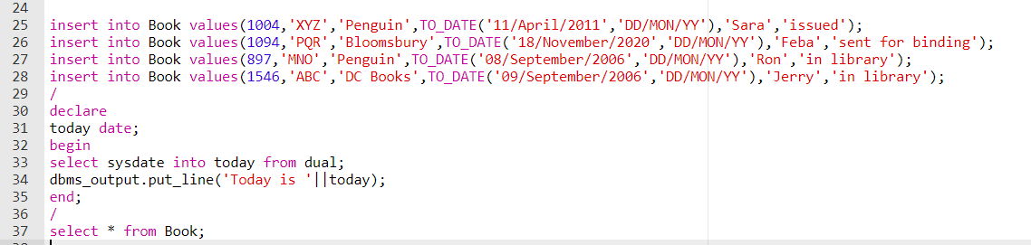

**OUTPUT:**

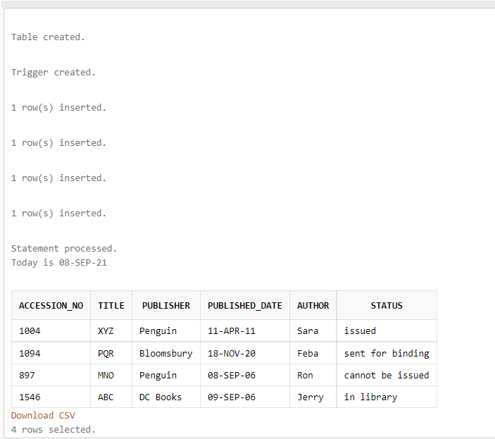

1. Create a table Inventory with fields pdtid, pdtname, qty and reorder_level. Create a **trigger** control on the table for checking whether qty<reorder_level while inserting values.

